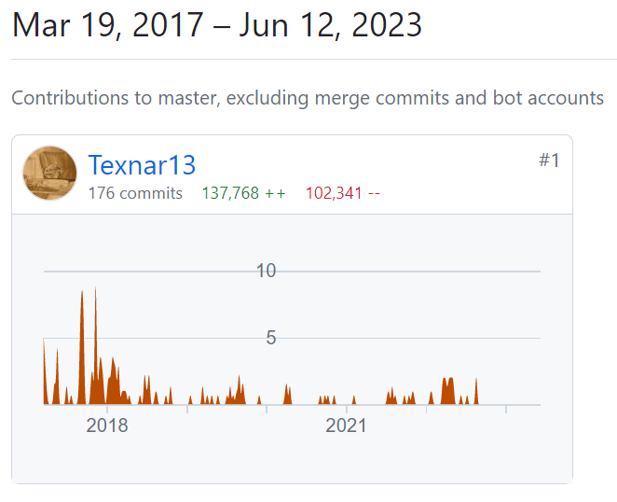

https://github.com/Texnar13/ItSchoolProject/graphs/contributors

